**Earthquake Simulation Model using various Scheduling Algorithms**

***Rishi Dinesh 19BAI1009, Pranav Balaji 19BAI1151***

**Abstract**

The aim of this project is to implement the various OS scheduling algorithms in an earthquake simulation to effectively carry out the various disaster management activities and minimise the casualties. In order to achieve this goal, we lay out the various steps that have to be followed after an earthquake and propose a parameterized simulation model that can be fine-tuned to carry out these steps in the most efficient manner. The various algorithms used in this project are FCFS, SJF, Priority and Round Robin schedulers.

**Stages of the Model**

Whenever an earthquake hits, there is always a huge loss of life and damage to property. Our model is a 5-tier architecture that aims to minimise this destruction. The first and immediate step is evacuation to a safe zone, followed by basic first aid and medical attention. As the victims are being tended to, food has to be collected from various sources and a food distribution centre has to be set up. Parallelly, the damaged buildings have to be inspected for faults and have to be sent for some basic patch-up work if necessary and the residents of those buildings have to be temporarily reallocated. The various stages of the simulation model are detailed below:

***Initialization***

An environment is randomly populated with people and properties. Each person has the following attributes: person ID, gender, age, and health points. Each property has the following attributes: property ID, a list of person IDs representing the residents and damage points.

An earthquake is then generated and the red zone is set. This includes randomly generating an epicenter and a magnitude between 6 and 10. The radius of the red zone will be proportional to the magnitude of the earthquake. Each person inside the red zone will become critical points. The health points of the people inside will drop from 100 to a random number.

For every critical point, the health drops by 1 every T1 minutes until the person is processed at the first aid camp and then drops by 1 every T2 minutes until the person is processed at the medical camp (T2>T1. T1 and T2 along with other variables are the parameters of the model that can be adjusted to get the best result).

***Evacuation – SJF***

Once the earthquake hits, N evacuation centers will be randomly generated with a predefined capacity within the red zone. Each of the critical points will move towards one of the N points and once the capacity is reached or when no more points are gathering at the center, the center signals for pickup (arrival time). The relief truck will drive to the evacuation center, pick the people up, and drive back to the relief camp. Evacuation center will be chosen based on shortest distance from relief camp (burst time). The shortest path (shortest job) is selected to ensure that maximum people are evacuated and that the death toll is reduced.

***First-Aid – Round Robin***

People from the red zone will arrive at the relief camp at a particular time (arrival time). This time will be same for people coming from one evacuation center and different for people coming from different centers. For each of these people, the burst time is calculated as (x*t1)/2 where x is the health when they arrive at the relief camp and t1 is the time taken to boost the health by 1 point. Round Robin ensures that all the people are given equal attention and that the basic injuries are treated on time.

***Medical attention – Priority***

Once a person has been treated with first aid at the relief camp, he/she will be moved to the medical camp for full medical attention (arrival time). The burst time here is calculated as (100-x) *t2 where x is the health when they arrive at the medical camp and t2 is the time taken to boost the health by 1 point. Priority is calculated as a combination of the person’s health status, age and gender. Priority is used as people in a more critical condition have to be given more importance as and when they arrive for medical attention.

***Food collection and distribution – SJF and Priority***

The process of food collection starts after the evacuation phase is completed. N food sources will be randomly populated on the map. When a food source is setup, it will send a signal indicating its ready state (arrival time). These food source will be obtained in a shortest-distance fashion (burst time).

When a person is fully nursed back to health at the medical camp, he/she will move to the food distribution center (arrival time). The burst time of each person is a representative of his/her hunger level. Hunger level is calculated as (100-x) *h where x is the original health level after the earthquake hit and h is the amount of energy the person needs to absorb 1 health point obtained at the medical and relief camp. Food will be distributed to the people on a priority basis with the priority being calculated as a combination of the person’s health status, age and gender.

***Inspection, Patch-up and Reallocation – FCFS and SJF***

The inspection process will start after the evacuation phase has been completed. An inspection camp will be setup at the epicenter of the earthquake. The arrival time could be the time at which the debris surrounding the property is cleared and the property sends a signal indicating that it is open for inspection. The burst time of the property is its distance from the epicenter. When a signal is received, an inspector from the inspection camp visits the property to assess the damage (FCFS manner).

If the damage points are greater than 50, the property has to be scheduled for patch up work and the residents have to be temporarily reallocated. The property is sent to be fixed after inspection (arrival time) and the burst time is calculated as (x-50) *t3 where x is the damage level and t3 is the time to fix 1 damage point. The properties will be patched up in a SJF manner.

**Parameters of the Model**

|  |  |
| --- | --- |
| Health drop rate | |
| T1 | 20 minutes |
| T2 | 30 minutes |
| *Population* | |
| 6-7 | 20 |
| 7-8 | 40 |
| 8-9 | 60 |
| 9-10 | 80 |
| *# Houses* | |
| 6-7 | 5 |
| 7-8 | 10 |
| 8-9 | 15 |
| 9-10 | 20 |
| *Area of Red Zone* | |
| 6-7 | 10Km |
| 7-8 | 20Km |
| 8-9 | 30Km |
| 9-10 | 40Km |
| *Initial Health Drop* | |
| 6-7 | 30-40 |
| 7-8 | 20-30 |
| 8-9 | 10-20 |
| 9-10 | 0-10 |
| *# Evacuation Centers* | |
| 6-7 | 2 |
| 7-8 | 3 |
| 8-9 | 4 |
| 9-10 | 5 |
| Buffer time | 15 minutes |
| *First Aid - Round Robin* | |
| Time Quantum | 10 minutes |
| t1 | 5 minutes |
| *Medical - Priority* | |
| Priority | Figure 1 |
| t2 | 10 minutes |
| *Food Collection - SJF* | |
| 6-7 | 3 |
| 7-8 | 4 |
| 8-9 | 5 |
| 9-10 | 6 |
| *Food Distribution - Priority* | |
| Priority | Figure 1 |
| h | 0.5 |
| *Rebuilding - SJF* | |
| t3 | 30 minutes |

The various parameters that can be adjusted to generate different simulations are given in the table. Parameters such as population, number of houses, area of red zone, initial health drop, number of evacuation centers and number of food collection centers vary with the magnitude of the earthquake generated (6-7 magnitude has different values compared to 7-8 and so on).

T1 and T2 represent the amount of time it takes for a person’s heath to drop by 1 until he/she is processed at the first-aid camp and medical camp respectively. t1 and t2 on the other hand denote the time taken to boost the health by 1 point at the first-aid camp and medical camp respectively.

t3 is the time taken to fix 1 damage point of a house and h is the amount of energy the person needs to absorb 1 health point obtained at the medical and relief camp.

Priority based schedulers use a formula (Figure1) that combines attributes such as age, gender and health status in order to assign a priority level to the person.

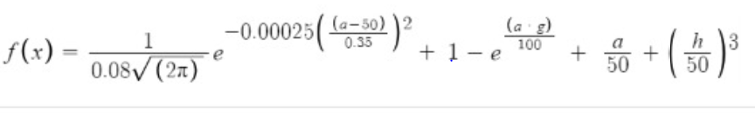

Figure 1 : Formula to calculate priority level

The formula given above is used by the priority schedulers to calculate the priority level based on age (a), gender (g) and health status (h). This formula will ensure that children and old people are given more priority than adults and that people in critical health are given more attention than those with a more stable health status.

**Screenshots**

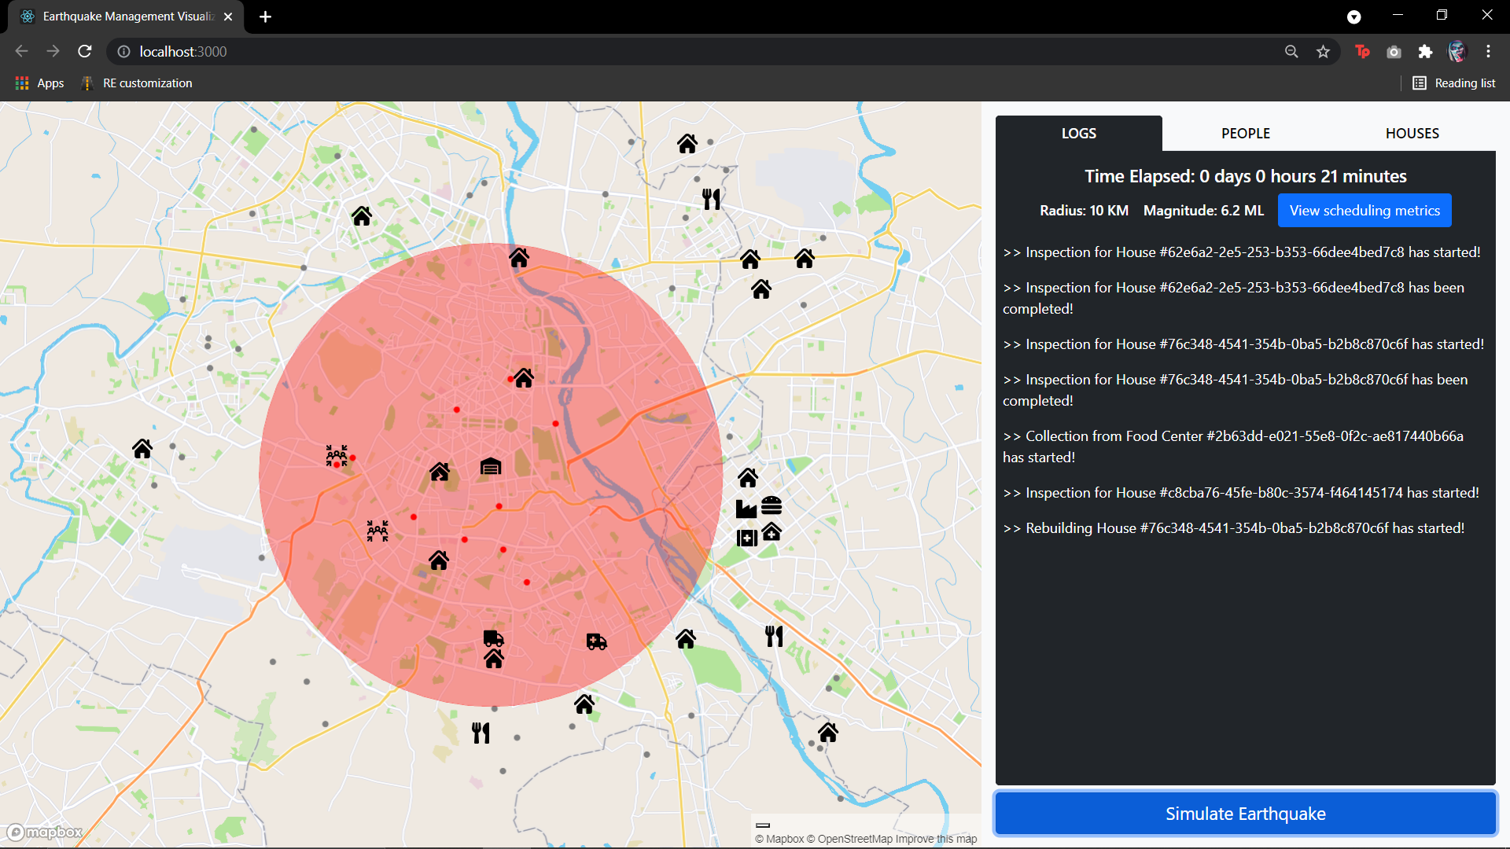

In the above screenshot, we can see that the earthquake has been initialized (red zone) and the people (red points) have started to move toward the evacuation centres. Simultaneously, we can see one truck collecting food from food sources and another truck going to houses for inspection. All the activities that take place during the simulation will be logged in the console on the right. A timer on top will keep track of the total time elapsed.

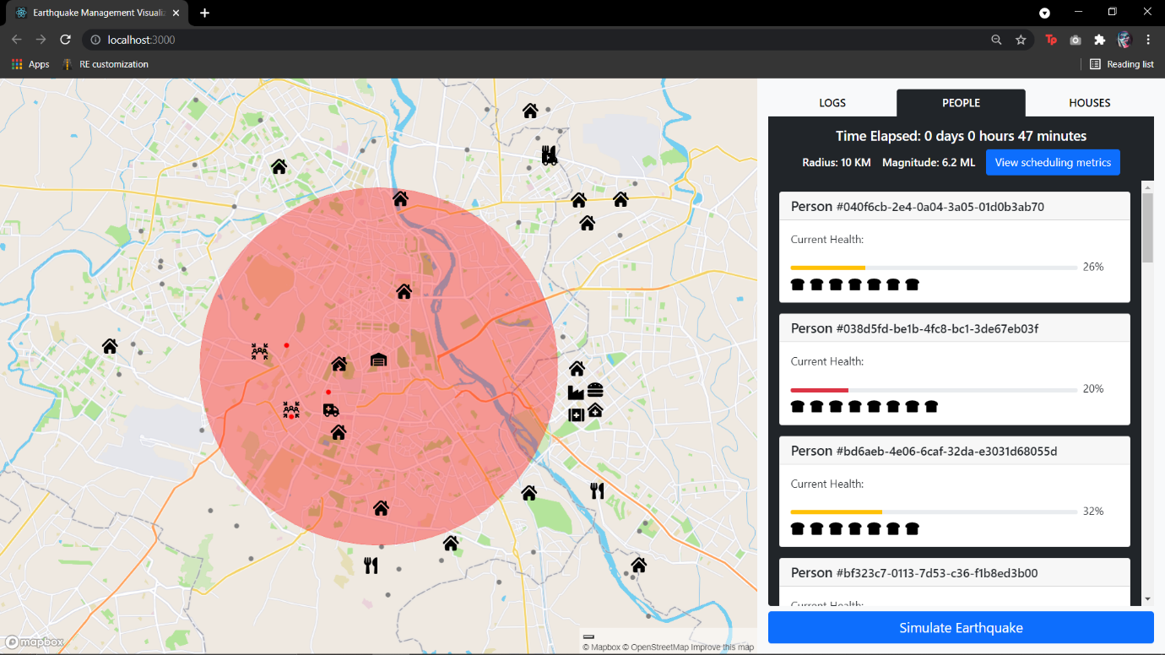

In the above image, we can see the current health status of each of the affected people along with their current energy level displayed below their respective health bars. These values will change as time progresses and as people are processed at first aid camps, medical camps, food distribution centres, etc.

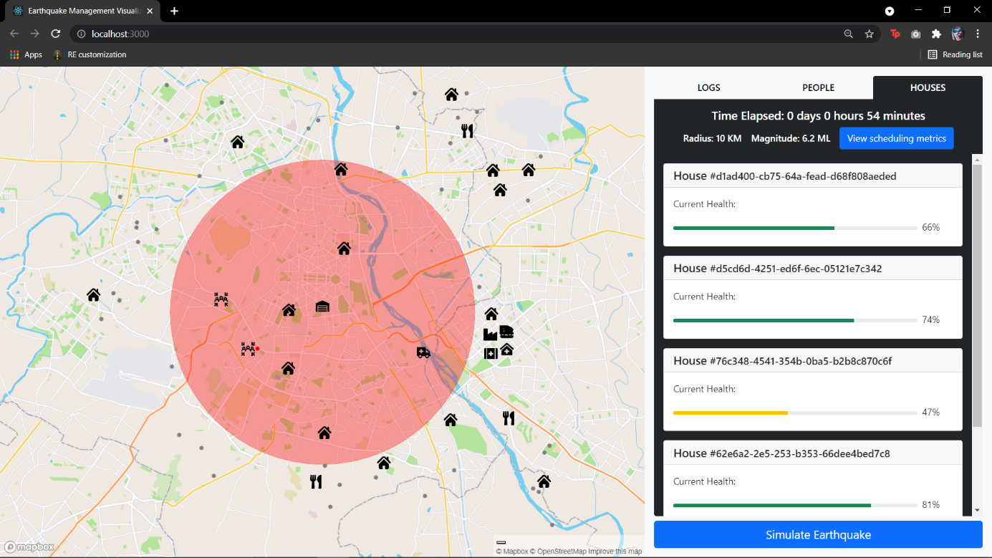

The above image displays the damage level of all the houses in the red zone. These houses will be inspected in an FCFS manner and their values will change as they are sent to be patched up.

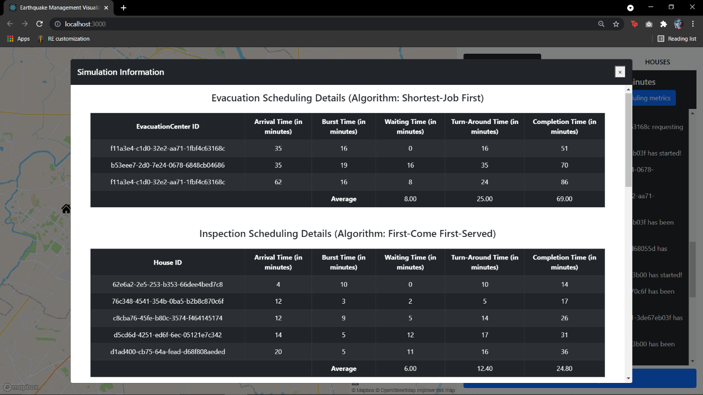

In the above image, we can see the final results of the simulation. Various metrics such as the waiting time, turn around time and completion time will be computed and displayed for each individual process in each of the different stages. These metrics can be used to evaluate the efficiency of the model.

**Hardware Requirements**

Since this project is a web application, it requires minimalistic hardware to run. The threshold is an i3 Processor based computer (or higher) with a memory of at least 1 GB and a hard drive storage of at least 50GB. It requires basic input and output devices such as a monitor, keyboard and mouse for navigation. The system must also be equipped with an internet connection to access the website.

**Software Requirements**

The only software required is a web browser such as Google Chrome, Microsoft Edge, Mozilla Firefox, Safari etc. This project will be developed to be platform independent and will thus be able to run on any browser-OS combination. Some recommended operating systems for a smooth user experience are the Windows version 7 or newer, macOS X v10.7 or higher or the popular Linux distribution, Ubuntu.